**[Project title]**

**WEB PROJECT (1)**

**FWD291**

**Full Stack Web Developer**

**Supervisor: [professor’s name]**

**Presented by:**

**Student 2 Name**

**SID #**

**Student 1 Name**

**SID #**

**Student 3 Name**

**SID #**

**Student 4 Name**

**SID #**

**Student 5 Name**

**SID #**

**Academic Year 1445 AH**

# Acknowledgement

# Abstract

# List of Tables

**List of Figures**

**List of Abbreviations**

# Table of Content

Table of Contents

Acknowledgement 2

Abstract 3

List of Tables 4

List of Figures 5

List of Abbreviations 6

Table of Content 7

1 Chapter 1: Introduction 9

1.1 Introduction 9

1.2 Problem Definition 9

1.3 Project Objectives 9

1.4 Project Scope 9

1.5 Project Timeline 9

1.6 Document Organization 9

2 Chapter 2: Literature Review 10

2.1 Introduction 10

2.2 Background 10

2.3 Related work and Similar Systems 10

2.4 Summary 10

3 Chapter 3: Project Requirements and System Analysis 11

3.1 Introduction 11

3.2 Requirements 11

3.2.1 Functional Requirements 11

3.2.2 Non-Functional Requirements 11

3.3 System Design 11

3.3.1 Use Case Diagram 11

3.3.2 Flow Chart 11

3.4 Development Methodology 12

3.5 Summary 12

4 Chapter 4: System Design 13

4.1 Introduction 13

4.2 Architectural design 13

4.3 Object Oriented Design 13

4.3.1 Class Diagram 13

4.3.2 Sequence Diagram 13

4.3.3 Activity Diagram 13

4.4 Database Design 13

4.5 User Interface Design 13

4.6 Summary 13

5 Chapter 5: Conclusion and Future Work 14

5.1 Conclusion 14

5.2 Web Project 2 Plan. 14

References 15

APPENDICES 16

# Chapter 1: Introduction

## Introduction

Traveling is one of the means of entertainment for people. Many of us love to travel and travel to different places, explore new places, and learn about new civilizations. Especially, we, as Saudis, are passionate about traveling, our region is diverse in nature, the North is not like the South, and the South is not like the East. In addition, each region differs in its climate and terrain.

## Problem Definition

Tourists and residents face several difficulties when searching for tourist places in Saudi Arabia, including the lack of guidance on the best products, foods, hotels, tourist places, etc., and in recent years with the emergence of the Internet and mobile phone networks, there have been many mobile phone applications and websites developed to help tourists in the Kingdom. Saudi Arabia, but most of these electronic solutions are not like that, so in general there is a problem in the Kingdom of Saudi Arabia that lies in the difficulty of introducing tourists to new civilizations and guiding them to places in a brief, useful and reliable way. Among the technical solutions that I offered to make life easier for these people is the availability of websites that It addresses this problem and provides multiple products, foods, and tourist places, and provides many places that can be searched through the site and see the evaluation and prices. Some other sites lacked the most prominent characteristics, such as not organizing their products into sections, and not providing details or an evaluation method, and these characteristics reduce From customers' use of the site

## Project Objectives

We aim to create a blog for people who travel the world and want to share their experiences and discoveries about the places they have visited. They can write articles about the cities, tourist attractions, activities, and restaurants they enjoyed. They can also provide ideas and tips for people who want to visit those places. Readers can interact with them and ask questions or seek advice. It seems like it will be useful for many people who are looking for real experiences and useful information before traveling.

We also aim to promote global culture and broaden people's horizons by exploring and learning about new places.

The creation of this website will contribute these objectives:

**1**. **Providing a Reliable Source**: The blog aims to be a trusted source for travelers seeking information about cities and places visited by others. Visitors can rely on the information provided by other travelers, as they describe their personal experiences, observations, and explorations of places.

**2**. **Sharing Experiences and Knowledge:** Different travelers can exchange their experiences and knowledge through the blog. Tips may be offered, favorite places shared, and fun activities recommended in various cities. New travelers can benefit from this information to enhance their personal experience and plan their future trips.

**3**. **Communication and Balance:** The project works on enhancing direct communication among travelers. People interested in visiting specific places can connect with those who have already visited them. Former travelers can provide advice, guidance, and answer any questions that new visitors may have.

**4**. **Encouraging Exploration and Adventure**: The blog can inspire readers to explore and discover new places. Articles and personal experiences can showcase the spirit of adventure, different cultures, and amazing tourist attractions awaiting visitors around the world**.**

**5. Building an Online Community:** The project can contribute to building an online community for travelers and travel enthusiasts. This community can serve as a platform for sharing, collaboration, and exchanging ideas and experiences in the field of travel and tourism.

## Project Scope

The project scope defines the boundaries and constraints within which the project operates. It clarifies what aspects of the problem will be addressed and what will be excluded, ensuring a focused and manageable endeavor.

## Project Timeline

This section outlines the projected timeline for the project, detailing key milestones, deadlines, and deliverables. It provides a roadmap for project management and ensures timely progress towards achieving objectives.

## Document Organization

The remainder of this document is organized as follows: Chapiter 2 will analyze the existing website that serve travel bloggers. Then, we will present the system analysis process that helps us study the site and its parts and define its goals. In chapiter 3, we will design our system by class and sequences diagrams. Then, we will design some user interface of our website. Chapiter 4 will be dedicated to the implementation of our website

# Chapter 2: Literature Review

## Introduction

In this chapter, we will review all the sites that serve travel bloggers. We will describe them and analyze the features of each one to benefit from their advantages and avoiding it disadvantages in developing our system.

## Related work and Similar Systems

**2.1.1 Analysis of existing systems**

There are many sites that have been developed in the past that provide travel blogs for people who want to go to tourism, and in this section, we will present the best of these sites**.**

**2.1.1.1 Thedollzter:**

The website **Thedollzter** ( <https://www.thedollztertravels.com/> ) is a website that blogs about travel tips, travel reviews, travel social media and other things of interest from around the world…………

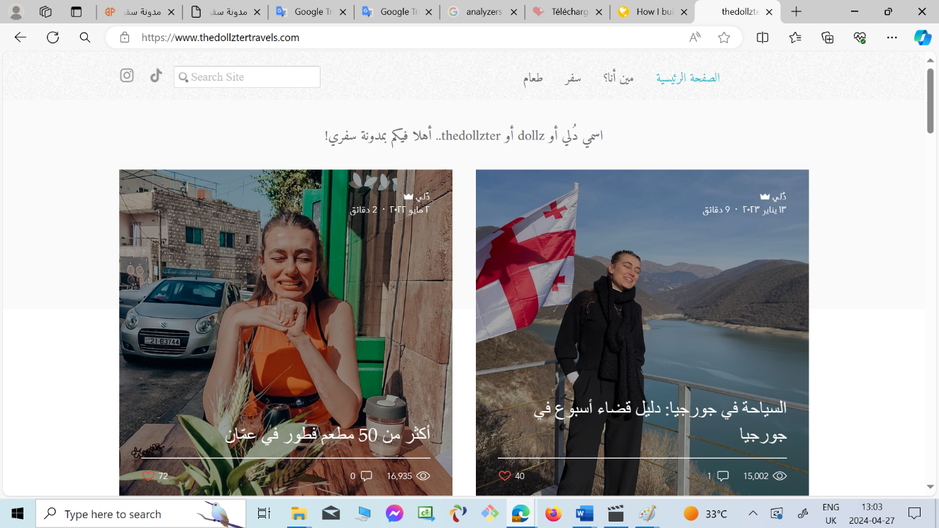

* **Advantages of Thedollzter**

-  It enables the user to view the most of the frequently asked questions,

- It enables to add photos of the places visited by the Dollez.

* **Disadvantages of Thedollzter**

The Thedollzter website only enable , Dollz , the site owner just talking about her personal journey, but :

- It can't enable the user to see other people's opinions about the blog or her travels.

- It can't enable the user to share his opinion about his travels.

- It did not enable the traveler to talk about prices in most areas.

- It did not enable the traveler to clarify whether these areas were safe for families or not.

**2.1.1.2 Travel Blog.com**

The website travel Blog.com (<https://safar22.com/> ) talks about the most famous tourist cities and the most important hotels for an enjoyable and comfortable stay.

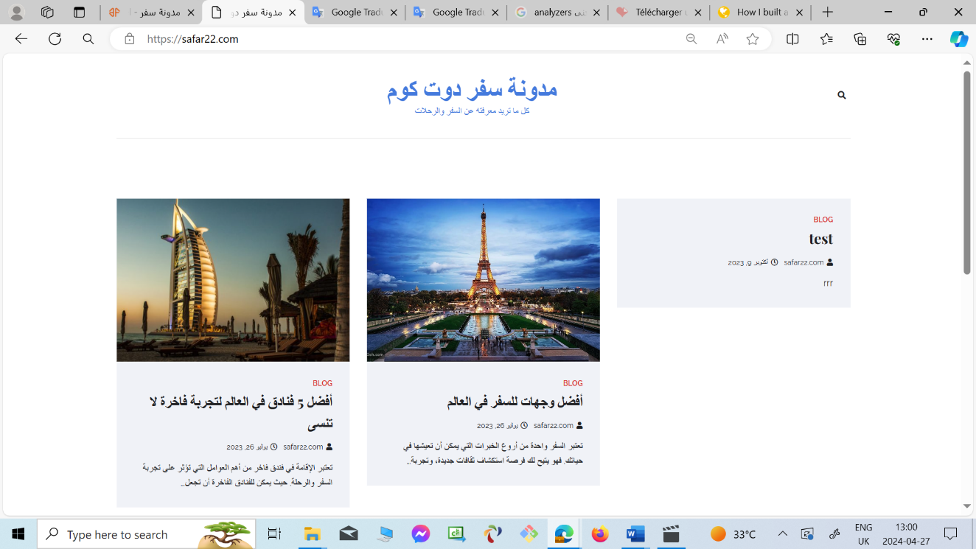

* **Disadvantages of Travel Blog.com**

- It did not talk about how to travel there and whether it is safe or not.

- It can't see people's opinions about this blog.

- It talks briefly about the areas and places to stay.

- It not provided pictures of the tourist cities that it talked about.

**2.1.1.3 Wanderlust's**

The website Wanderlust's ([https://wander](https://wanderlusters.com/)

[lusters.com/](https://wanderlusters.com/)(

It is a travel blog that provides tips and information about traveling, in addition to sharing the owners' personal travel experiences.

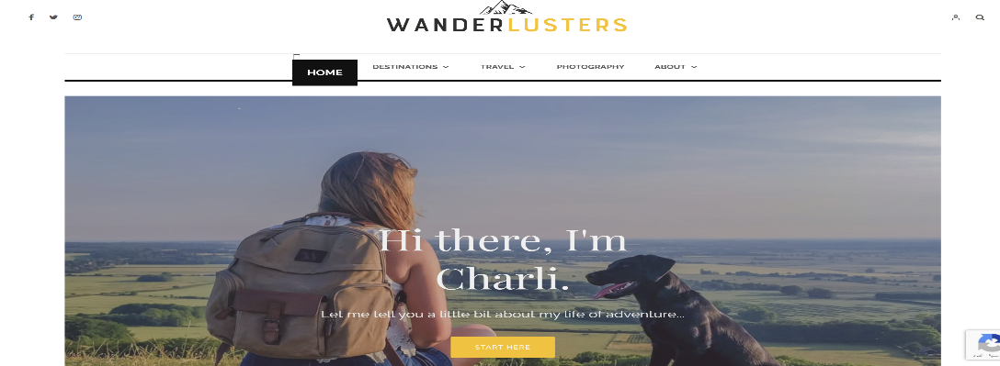

* **Advantages of Wanaderlust's**:

-I have answered all the questions asked and interacted with readers.

- There are pictures and some videos for each trip.

- She detailed the places she visited.

- gave useful tips and information.

* **Disadvantages of Wanaderlust's**:

-I don't see information about costs and budget for some of the places I went to.

-I can't share my experience, she's only speaking from her own experience.

**2.1.1.4 Travel hero:**

The website **Travel hero** ( <https://travelhero.app/blog/>)

Travel Hero is the first interactive travel guide that gives you the travel experience to build your trip based on your mood and budget with the help of travel experts.

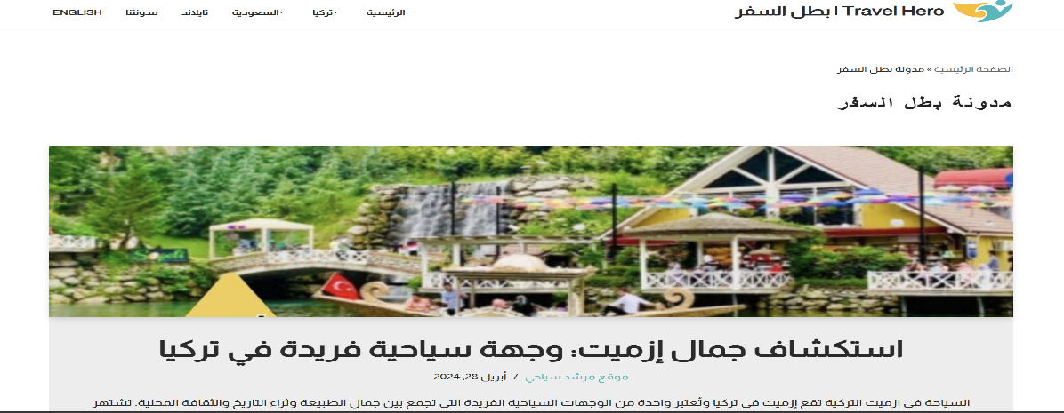

* **Advantages of Travel hero:**

- gave information about some places.

- talked about restaurants, hotels, and possible activities.

- added photos and videos.

* **Disadvantages of Travel hero:**

-I cannot comment on blogs.

-To learn more information, you must subscribe.

-do not provide links to other websites or blogs that are useful to travelers.

- there is not enough advice for travelers.

## Summary

The table below shows the basic parameters of the chosen site. We conducted a comparative analysis of other sites based on several key characteristics.

|  |  |  |  |  |
| --- | --- | --- | --- | --- |
| feature | Thedollzter | Travel Blog.com | Wanderlust's | Travel hero |
| Attach photos or video of the country | + | + | + | + |
| Information about the country | + | _ | + | _ |
| Add a comment | _ | _ | _ | _ |
| See people's opinions | _ | _ | _ | _ |
| User sharing his opinion | _ | _ | _ | _ |
| User research about the countries he wants | _ | _ | _ | _ |

# Chapter 3: Project Requirements and System Analysis

## 

## Introduction

In this chapter, the proposed system is analyzed by a comprehensive discussion of feasibility study and functional and non-functional requirements. Further, it discusses the high-level architecture and the development methodology to be followed to achieve the project.

## Requirements

This section summarizes the functional and non-functional requirements of the projects’ deliverables. Depending on the nature of the requirements, they will be categorised in to two categories, functional and non-functional.

### Functional Requirements

Functional requirements are a description of the system's behaviour in terms of relevance to the system's function. In our system, we have two users: the admin and the user, each of which has its own processes.

* **User**

Our website will allow user to:

* Create an account and set their credentials.
* Update profile information.
* Register or create an account.
* View all information about the city and its evaluation by others.
* Add his rating for cities and reviews.
* Quickly search for the desired city.
* View ratings for each city when selected.
* Communicate with customer service when needed.
* Read comments.
* Enter the desired city section.
* Read the evaluation of the desired city and its section!
* Search for the most important monuments in the desired city.
* View location information for the place.
* **Admin**
* Log in
* verify customer data
* Responding to customer inquiries
* Processing and updating requirements.
* Review the evaluation for customer satisfaction.

### Non-Functional Requirements

The non-functional requirement describes the performance characteristic of the system. We can specify the non-functional requirements of our website through the following points:

* **Accessibility and availability:**

All customers can access the site

* **Capacity:**

The ability to contain a large number of data and a large number of users can register on the site.

* **Efficiency:**

The site is distinguished by its efficiency because it is an unusual idea and will solve the problem of many people who suffer from finding archaeological and tourism sites in the Kingdom.

* **Privacy and security:**

It has high privacy as all user data is secure and no one can access it without permission

## System Analysis

This section highlights the design of the proposed website by illustrating the application flow via flowchart and use case diagram.

### Use Case Diagram

Use case diagrams visually depict the interactions between system users and the system itself

### Flow Chart

Flow charts provide a graphical representation of the system's processes and workflows, depicting the sequence of actions and decision points within the system.

## Development Methodology

The methodology of the project is different and numerous, including six different methodologies, the most common of which is:

- Waterfall Model,

- V-Shaped Model,

- Iterative Model,

- Spiral Model,

- Big Bang Model,

- Agile Model.

In this project, we rely on the waterfall model, which is the simplest model of the project's methodology and depends on six simple and easy steps for all team members and helps us move between the steps without any problems especially for people who do not have high experience in developing and managing projects. The figure below ( describes the phases of the iterative waterfall.)

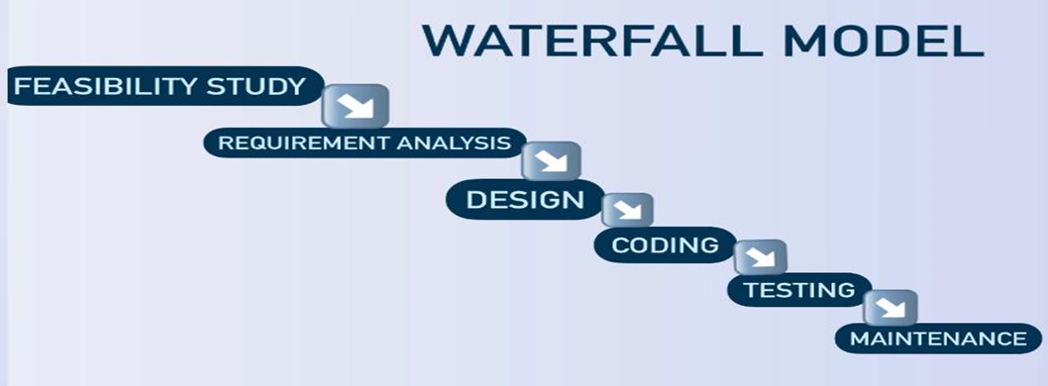

.

## Summary

The chapter concludes with a summary of the project requirements and system analysis, encapsulating key insights and decisions that inform the subsequent phases of system development.

**APPENDICES**

**2:4 Use Case Diagrams**

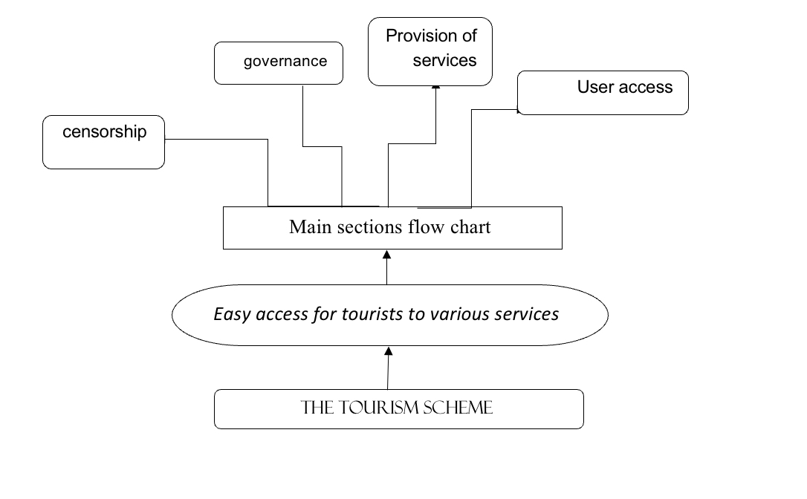

**\*\*the tourism scheme\*\***

A flowchart for a system that allows users to access a variety of services, including healthcare, education, and transportation. The flowchart shows how these services are related to each other and how they interact with each other.

Users can access the system through a variety of devices, such as smartphones, tablets and computers.

Service providers provide a variety of services through the system.

Stakeholders participate in the management and supervision of the system.

The system is designed to be easy to use and efficient

It uses a variety of technologies to ensure that users get to the services they need quickly and easily.

**The flow chart is divided into four main sections:**

1- User access

2- Provision of services

3- Governance

4- Censorship

**1.User access**

The user access section of the flowchart shows how users can access the system. Users can access the system through a variety of devices, such as smartphones, tablets and computers. They can also access the system through a variety of channels, such as the web, mobile applications and

kiosks. Once the user has access to the system, he can browse the available services and select the ones he needs. The system will then provide the user with instructions on how to use the service.

**2. Provision of services**

The service delivery section of the flowchart shows how services are delivered to users. Service providers provide a variety of services through the system. These services can be classified into three main groups: Healthcare services Education services Transportation services

Healthcare services include things like scheduling appointments, seeing doctors, and filling prescriptions. Education services include things like registering for courses, taking tests, and accessing course materials. Transfer services include such things as booking flights, tracking public transport and paying fares.

Once the user has chosen the service, the system will connect him to the appropriate service provider. The service provider will then deliver the service to the user.

**3.Governance**

The governance section of the flowchart shows how the system is managed. Stakeholders are involved in the management and supervision of the system.

Stakeholders include users, service providers and government agencies. Stakeholders are responsible for determining the overall direction of the system and making sure that it meets the needs of all users. They are also responsible for monitoring the performance of the system and making sure that it works effectively.

**4.Censorship**

The control section of the flowchart shows how to supervise the system. The system is supervised by a variety of bodies, including government agencies, independent organizations and user groups. These bodies are responsible for ensuring that the system operates in a fair, transparent and accountable manner. They are also responsible for investigating any complaints or concerns that users may have.

The system shown in the flowchart is a complex and developed system that has the potential to improve the lives of many people.

## Summary

By providing users with access to a variety of services in an easy-to-use and efficient way, the system can help make it easier for people to get the things need

# Chapter 4: System Design

## Introduction

This chapter presents the system design considering the main dimensions of our proposed system. Further, it discusses the various aspects of system design, including architectural, object-oriented, Database design, and user interface design.

## Architectural design

The project outlines the high-level architecture of the proposed system, defining its structural components, interfaces, and relationships.

## Object Oriented Design

### Class Diagram

Class diagrams illustrate the classes, attributes, and relationships among objects within the system.

### Sequence Diagram

Sequence diagrams visualize the dynamic interactions between objects over time, depicting the flow of messages and method invocations among objects.

### Activity Diagram

Activity diagrams represent the workflow or procedural logic of a system, capturing the sequence of activities and decision points involved in a process.

## Database Design

This section focuses on the design of the system's database, including the creation of entity-relationship diagrams (ERDs) and schema definitions.

## User Interface Design

The project details the design of the user interface, encompassing the layout, navigation, and visual elements of the system.

## Summary

The chapter concludes with a summary of the system design phase.

# Chapter 5: Conclusion and Future Work

## Conclusion

The conclusion chapter summarizes the project's key findings, achievements, and any insights gained.

## Web Project 2 Plan.

This section provides an overview of planned implementation activities while also outlining the timeline and milestones for the next phase.

**References**

The references section provides a detailed list of all sources cited or consulted during the project, adhering to a specified citation format for academic integrity.

[1] P. Likarish, E. Jung, D. Dunbar, T. E. Hansen, and J. P. Hourcade, "B-APT: Bayesian Anti-Phishing Toolbar," 2008 IEEE International Conference on Communications, 2008, pp. 1745-1749, doi: 10.1109/ICC.2008.335.

[2] Phishing website dataset available at https://www.kaggle.com/

[3] http://s3.amazonaws.com/alexa-static/top-1m.csv.zip

[4] . <https://github.com/mitchellkrogza/Phishing.Database/blob/master/phishing-domains-ACTIVE.txt>